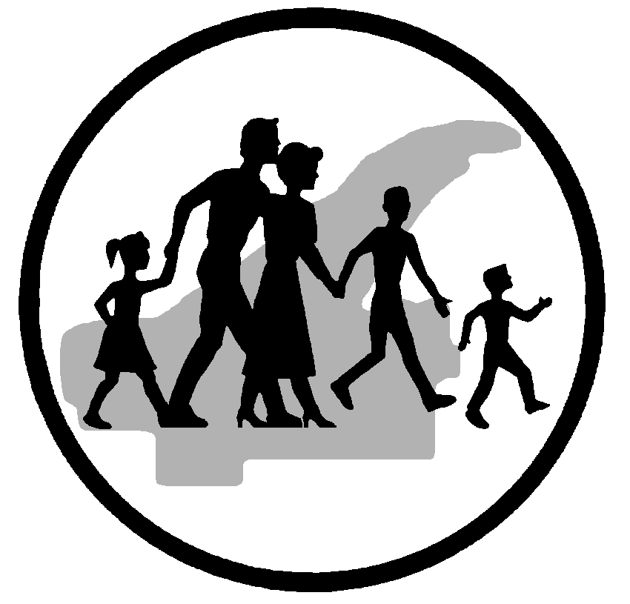

Applied Behavioral Analysis (ABA) Aide

Posting Length: 06/28/18 -
Until Filled

Copper Country Mental Health, a four-county community mental health center, is recruiting part-time Applied Behavioral Analysis Aides.

Staff in these positions will carry out interventions with children and young adults with Autism. These interventions are directed toward developing functional communication, independent self-care tasks, receptive language, expressive language, play behaviors, social skills, imitation, and/or any additional behaviors that will enable the child or young adult to more readily integrate with typically developing peers. Positions are based in Houghton. Hours will include day and evenings hours.

Requirements include: HSD/GED, valid MI driver's license and must pass a criminal background check.

Hourly Wage $11.80/hour with fringe benefits.

Application Packets can be picked up from:
Copper Country Mental Health
Human Resources Department
901 W. Memorial Drive
Houghton, MI 49931
EOE

